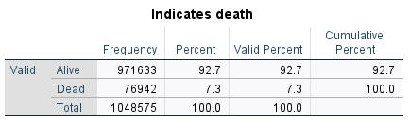
Figure 1
Figure 1 is a frequency table of death. From this, it seems that 92.7% of people that were recorded ended up living and 7.3% of people ended up dying.
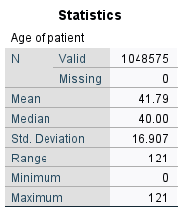
Figure 2
Figure 2 displays descriptive statistics on the patient age variable. The mean age is 41.79 and the median age is 40. The standard deviation of the distribution is 16.907 years. The maximum age is 121 and the minimum is 0. This means that the range for the distribution is 121 years. It seems that the distribution is roughly normal since the mean and median are close.

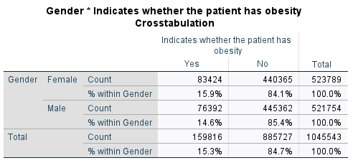
Figure 3
Figure 3 is a cross-tab of gender and indications of obesity. From this, it seems that it is about even for both genders to either be obese or not obese with a slightly higher likelihood for women to be obese than men with a 1.3% difference.
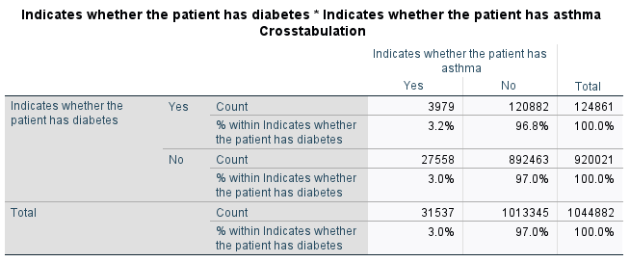
Figure 4
Figure 4 is a cross-tab of indications of diabetes and indications of asthma. From this, it seems that it is about even for someone with or without asthma to have diabetes.

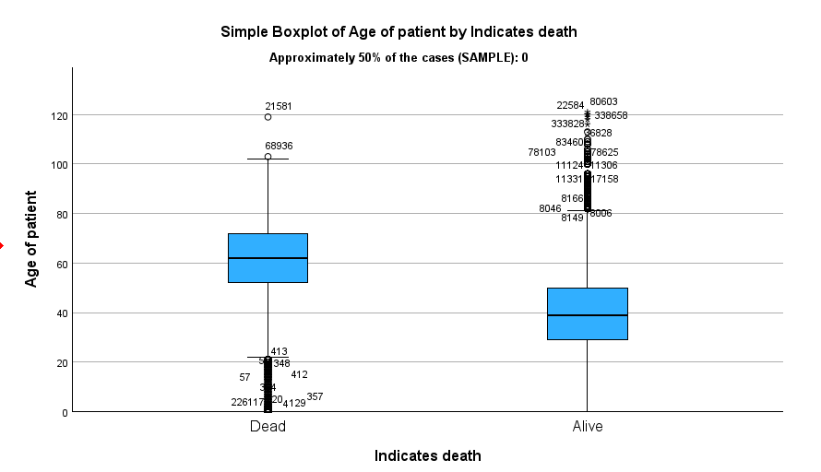
Figure 5
Figure 5 is comparative boxplots of the training set. It compares the response variable of indication of death by the variable age. It appears that the patients that lived have a median age of about 40 while the patients that died had a median age of about 60. The dead distribution appears to be skewed left since it has many outliers below its minimum age and the alive distribution appears to be skewed to the right since it has many outliers above its maximum age.

Other CHAID models
We ran many CHAID models. We attempted to change the tree depth, and this made the tree way too large, so we stuck with the default option of three. We also changed the size of the minimum cases for the parent and child nodes. We started with a low amount below 1,000 and this gave such a large tree that it did not even output. Then, we went by values of 1,000 from 1,000 to 20,000 for the minimum parent node size and then picked the model that had the best risk and if it was tied, we chose the simplest tree. If this was also the same, then we picked the model that had the lower amount required for the minimum parent node size.

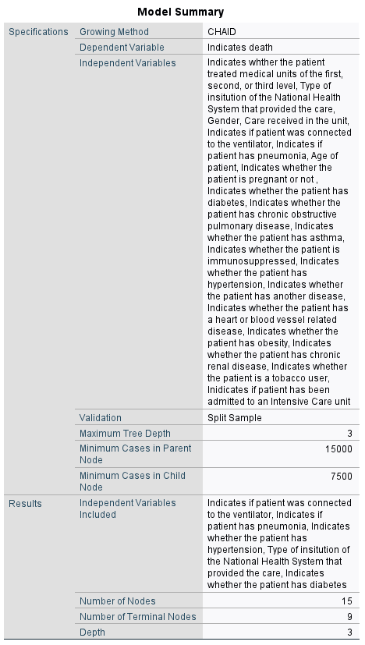
Figure 6
Figure 6 is the model summary for the training data using the CHAID growing method. It has a dependent variable that indicates if the patient died or not. The sample was split by the test variable for the training and validation sets. The maximum tree depth is 3 with the minimum number of cases per parent node being 15000 and the minimum number of cases per child node being 7500. 5 independent variables were used, and this ended up giving the tree 15 total nodes, with 9 of these being terminal nodes.

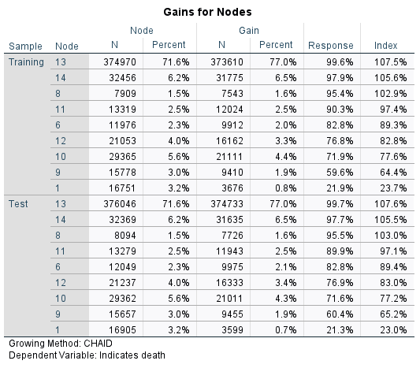
Figure 7
(Ignore testing set gains)
Figure 7 is the gains table for the terminal nodes in the training data. Based on this data, node 13 has the highest target response of people being alive, and its alive % is 7.5% higher compared to the overall alive %. Node 13 also contains the highest percent of people alive, with 77.0% of the people within its node. Node 13 also contains the highest percent of people with 71.6% of them. Lastly, node 1 has the lowest target response, with an alive % 76.3% lower compared to the overall alive %.
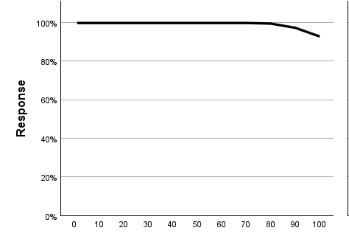
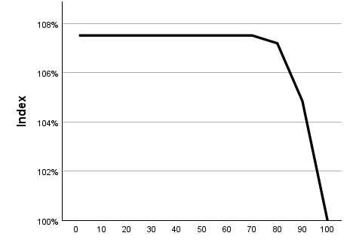
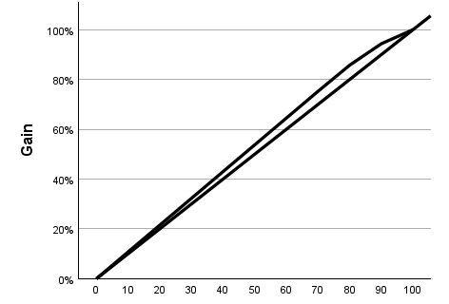

Figures 8, 9, 10
Figure 8 is the gains plot of the gain and the percentile. Since, the total number of people that were alive is about 486000, 50% of this amount is roughly 243000. The upper bound of the graph seems to line up with about 55%, which of 486000 is 267300. This means that the model benefit area for this model is about 24300.
Figure 9 is the response plot of response and percentile for the training data based on the target variable of a person being alive. Given this plot, the top 50% of people had an alive % of a little less than 100%. Then, the plot also shows that for all of the people the alive % will be slightly above 90%.
Figure 10 is an index plot of index and percentile for the training data based on the target variable of a person being alive. Given this plot, the top 50% of people had an alive % about 7.5% higher than the overall.
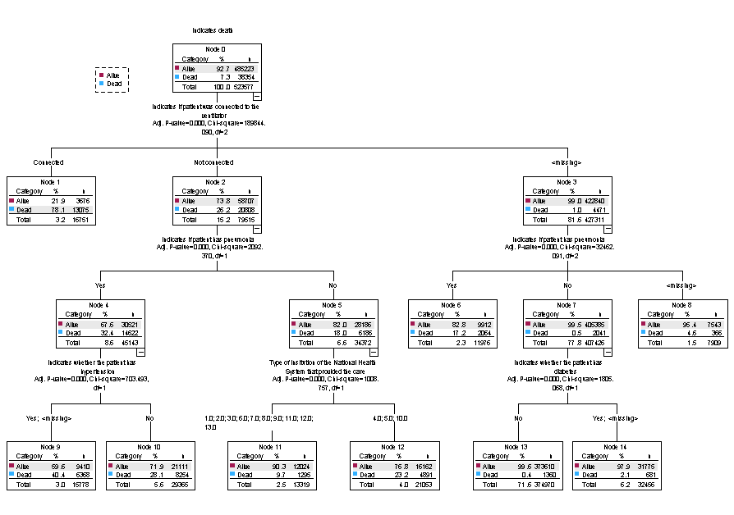
Figure 11
Based on the decision tree shown in figure 11, there are multiple types of people that stayed alive. The people that are the most likely to live are people that have a missing value for the ventilator, do not have pneumonia, and do not have diabetes, with a percent of people alive being 99.6%. The next most likely people to live are people that have a missing value for the ventilator, do not have pneumonia, and either do or are missing if they have diabetes, with a percent of people alive being 97.9%. The type of person that is the least likely to live is a person who was connected to the ventilator, with a dead percent of 78.1%. The next least likely type of person to live is a person who was not connected to the ventilator, does have pneumonia, and either does or is missing if they have hypertension, with a dead percent of 40.4%.
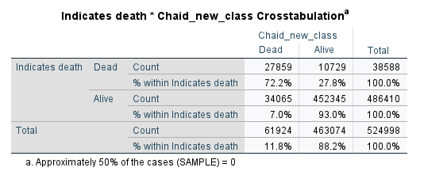
Figure 12
Disclaimer: Threshold is 0.75 to be classified as alive or dead.

Risk = 44794/523577 = 0.085
Sensitivity = 93.0%
Specificity = 72.2%
As shown in figure 12, the risk estimate for the testing data set is 0.085. This means that about 8.5% of the overall responses were incorrectly predicted in the testing set. The sensitivity for the testing set is 93.0% and the specificity for the testing set is 72.2%. Based on the testing set, the model does well at predicting if people lived, and the model does decent at predicting if people died.

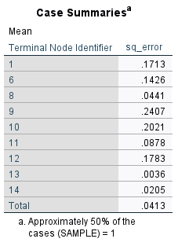
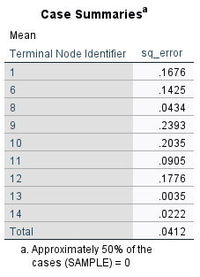

Training = 1
Testing = 0

Figure 13
Figure 13 displays the ASE for the training and testing nodes. The average square error for terminal node 9 is 0.2393 and 2407. This means that the average squared difference between the predicted values and the actual values is about 0.24. This is the highest average square error of the training and testing nodes, so this means that this node was predicted with the least accuracy. The average square error for terminal node 13 is about 0.003. This means that the average squared difference between the predicted values and the actual values is about 0.003. This is the lowest average square error of the training and testing nodes, so this means that this node was predicted with the most accuracy. This also displays the overall ASE. This means that the average squared difference between the predicted values and the actual values is 0.0412. The ASE for the training and testing nodes are very similar to each other, so there does not appear to be overfitting in the data.

Other Exhaustive CHAID models
We ran many Exhaustive CHAID models. Similar to the CHAID, we attempted to change the tree depth, and this made the tree way too large, so we stuck with the default option of three. We also changed the size of the minimum cases for the parent and child nodes. We started with a low amount below 1,000 and this gave such a large tree that it did not even output. Then, we went by values of 1,000 from 1,000 to 25,000 for the minimum parent node size and then picked the model that had the best risk and if it was tied, we chose the simplest tree. If this was also the same, then we picked the model that had the lower amount required for the minimum parent node size.

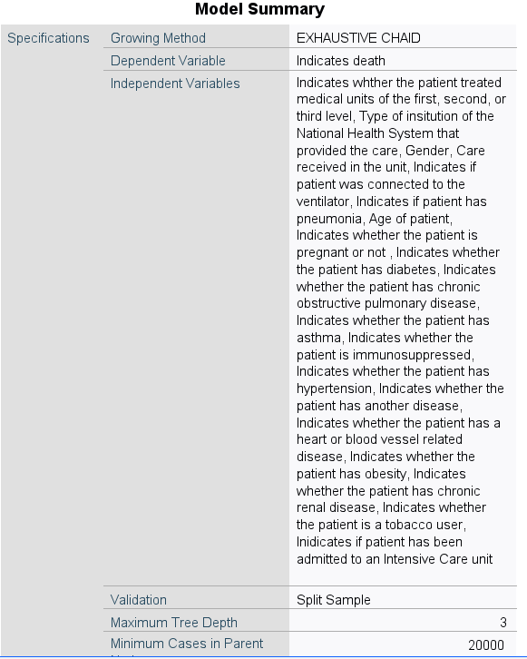
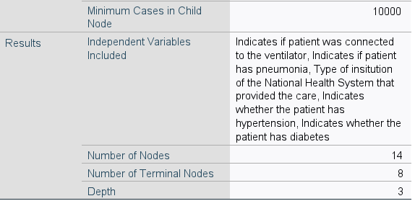
Figure 14
Figure 14 is the model summary for the training data using the Exhaustive CHAID growing method. It has a dependent variable that indicates if the patient died or not. The sample was split by the test variable for the training and validation sets. The maximum tree depth is 3 with the minimum number of cases per parent node being 20000 and the minimum number of cases per child node being 15000. 5 independent variables were used, and this ended up giving the tree 14 total nodes, with 8 of these being terminal nodes.

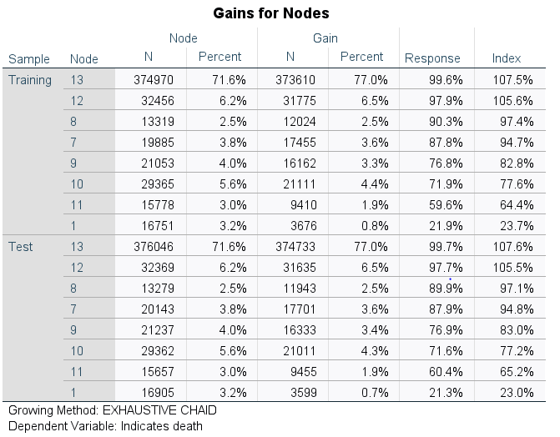
Figure 15
(Ignore testing set gains)
Figure 15 is the gains table for the terminal nodes in the training data. Based on this data, node 13 has the highest target response of people being alive, and its alive % is 7.5% higher compared to the overall alive %. Node 13 also contains the highest percent of people alive, with 77.0% of the people within its node. Node 13 also contains the highest percent of people with 71.6% of them. Lastly, node 1 has the lowest target response, with an alive % 76.3% lower compared to the overall alive %.

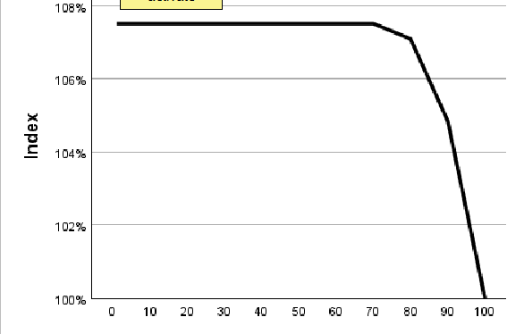
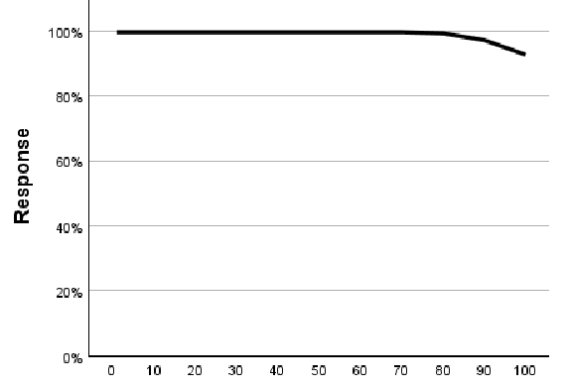
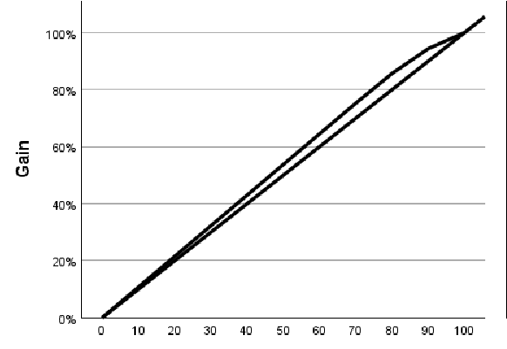
Figures 16, 17, 18
Figure 16 is the gains plot of the gain and the percentile. Since, the total number of people that were alive is about 486000, 50% of this amount is roughly 243000. The upper bound of the graph seems to line up with about 55%, which of 486000 is 267300. This means that the model benefit area for this model is about 24300.
Figure 17 is the response plot of response and percentile for the training data based on the target variable of a person being alive. Given this plot, the top 50% of people had an alive % of a little less than 100%. Then, the plot also shows that for all of the people the alive % will be slightly above 90%.
Figure 18 is an index plot of index and percentile for the training data based on the target variable of a person being alive. Given this plot, the top 50% of people had an alive % about 7.5% higher than the overall.

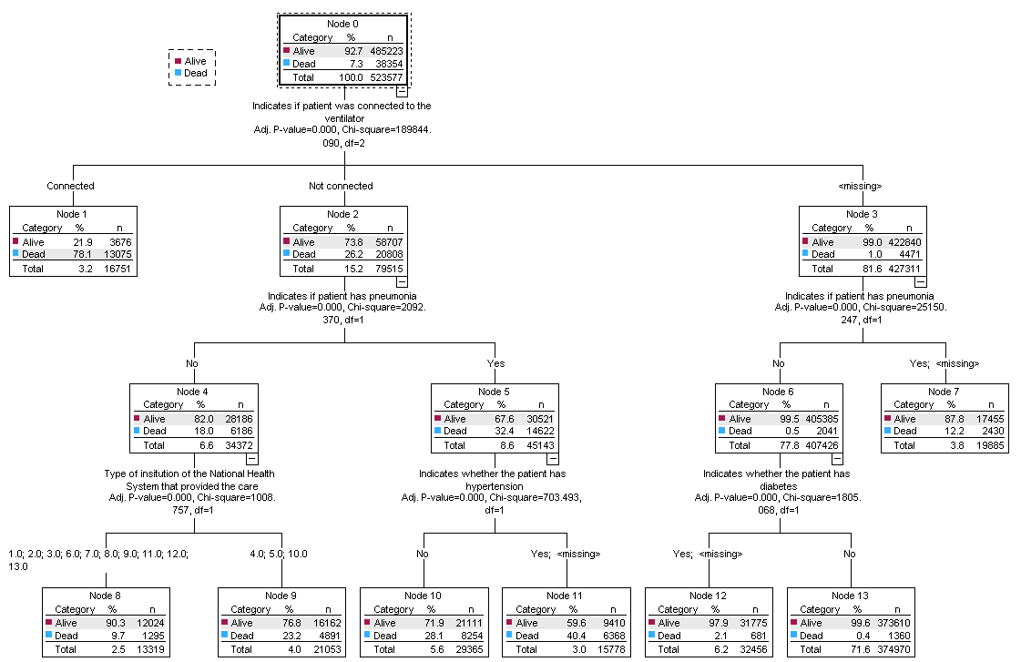
Figure 19
Based on this decision tree shown in figure 19, there are multiple types of people that stayed alive. The people that are the most likely to live are people that have a missing value for the ventilator, do not have pneumonia, and do not have diabetes, with a percent of people alive being 99.6%. The next most likely people to live are people that have a missing value for the ventilator, do not have pneumonia, and either do or are missing if they have diabetes, with a percent of people alive being 97.9%. The type of person that is the least likely to live is a person who is connected to the ventilator, with a dead percent of 78.1%. The next least likely type of person to live is a person who was not connected to the ventilator, does have pneumonia, and either does or is missing if they have hypertension, with a dead percent of 40.4%.

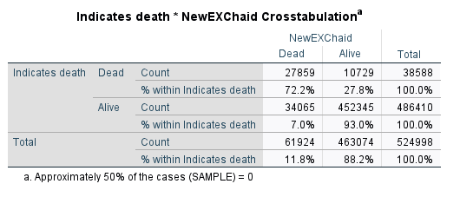
Figure 20
Disclaimer: Threshold is 0.75 to be classified as alive or dead.

Risk = 44794/524998 = 0.085
Sensitivity = 93.0%
Specificity = 72.2%
As shown in figure 20, the risk estimate for the testing data set is 0.085. This means that about 8.5% of the overall responses were incorrectly predicted in the testing set. The sensitivity for the testing set is 93.0% and the specificity for the testing set is 72.2%. Based on the testing set, the model does well at predicting if people lived, and the model does decent at predicting if people died.

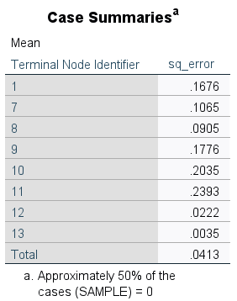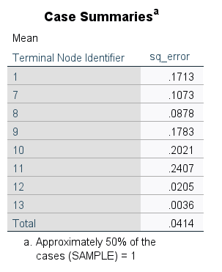
Figure 21

Figure 21 displays the ASE for the training and testing nodes. The average square error for terminal node 11 is 0.2393 and 2407. This means that the average squared difference between the predicted values and the actual values is about 0.24. This is the highest average square error of the training and testing nodes, so this means that this node was predicted with the least accuracy. The average square error for terminal node 13 is about 0.003. This means that the average squared difference between the predicted values and the actual values is about 0.003. This is the lowest average square error of the training and testing nodes, so this means that this node was predicted with the most accuracy. This also displays the overall ASE. This means that the average squared difference between the predicted values and the actual values is 0.0413. The ASE for the training and testing nodes are very similar to each other, so there does not appear to be overfitting in the data.

Other CART models
We ran many CART models. We attempted to change the pruning option, and turning it off produced a much larger tree. We also changed the maximum tree depth, but most of the trees did not reach the maximum anyway. Plus, we changed the size of the minimum cases for the parent and child nodes. We started with a low amount below 1,000 and this was actually okay. We still went above those values till about 15,000 for the minimum parent node size and then picked the model that had the best risk and if it was tied, we chose the simplest tree. If this was also the same, then we picked the model that had the lower amount required for the minimum parent node size.
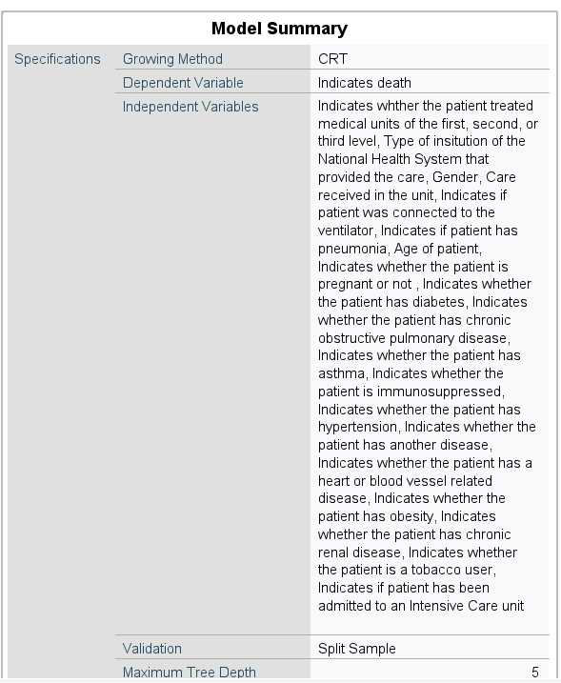
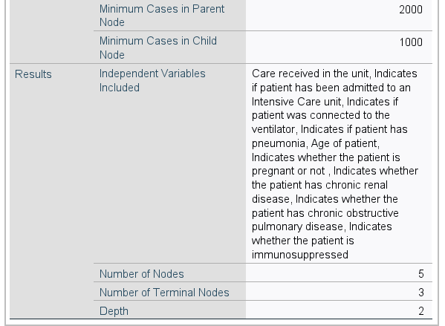
Figure 22
Figure 22 is the model summary for the training data using the CART growing method. It has a dependent variable that indicates if the patient died or not. The sample was split by the test variable for the training and validation sets. The maximum tree depth is 5 with the minimum number of cases per parent node being 2000 and the minimum number of cases per child node being 1000. 9 independent variables were used, however this was reduced with pruning, so this ended up giving the tree 5 total nodes, with 3 of these being terminal nodes.

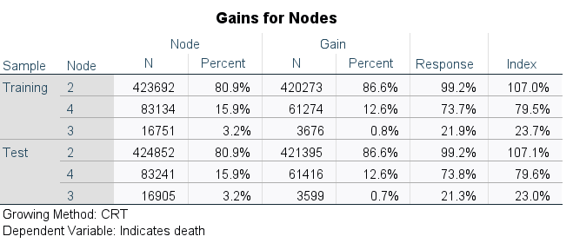
Figure 23
(Ignore testing set gains)
Figure 23 is the gains table for the terminal nodes in the training data. Based on this data, node 2 has the highest target response of people being alive, and its alive % is 7% higher compared to the overall alive %. Node 2 also contains the highest percent of people alive, with 86.6% of the people within its node. Node 2 also contains the highest percent of people with 80.9% of them. Lastly, node 3 has the lowest target response, with an alive % 76.3% lower compared to the overall alive %.

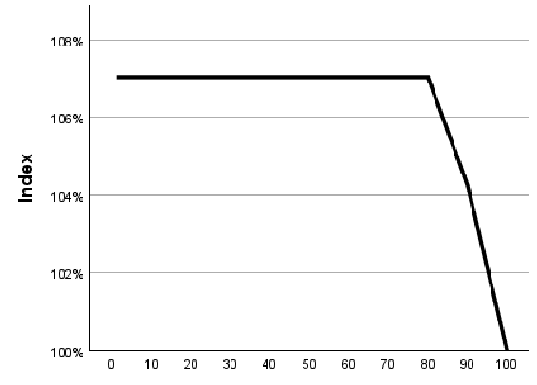
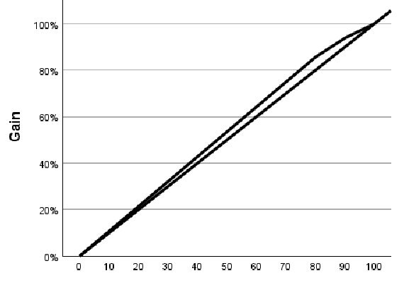
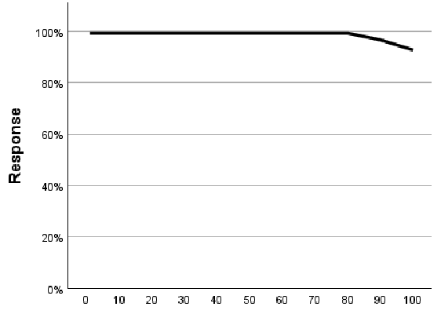
Figures 24, 25, 26

Figure 24 is the gains plot of the gain and the percentile. Since, the total number of people that were alive is about 486000, 50% of this amount is roughly 243000. The upper bound of the graph seems to line up with about 55%, which of 486000 is 267300. This means that the model benefit area for this model is about 24300.
Figure 25 is the response plot of response and percentile for the training data based on the target variable of a person being alive. Given this plot, the top 50% of people had an alive % of a little less than 100%. Then, the plot also shows that for all of the people the alive % will be slightly above 90%.
Figure 26 is an index plot of index and percentile for the training data based on the target variable of a person being alive. Given this plot, the top 50% of people had an alive % about 7% higher than the overall.

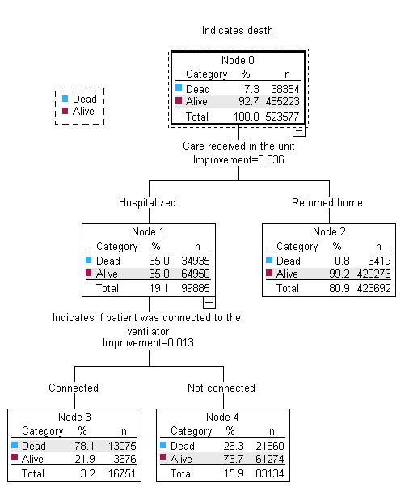
Figure 27
Based on this decision tree in figure 27, there are two types of people that stayed alive. The people that are the most likely to live are people that were sent home upon receiving care with a percent of people alive being 99.2%. The next most likely people to live are people that were hospitalized and were not connected to the ventilator, with a percent of people alive being 73.7%. The type of person that is the least likely to live is a person who is hospitalized and connected to the ventilator, with a dead percent of 78.1%.
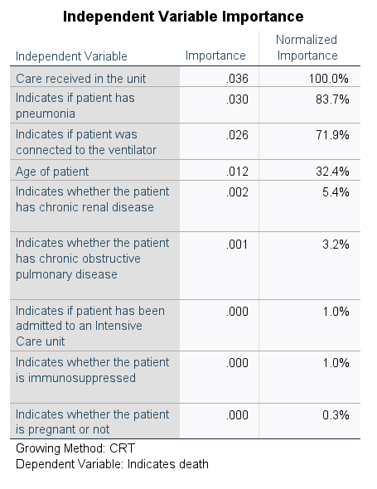
Figure 28
Figure 28 is the chart of independent variable importance when it comes to predicting the response variable of whether a person lives or not. The most important independent variables when it comes to predicting the response is the care received in the unit, followed by pneumonia, and then the connection to the ventilator. The least important independent variables when it comes to predicting the response is the immunosuppressed and pregnancy.

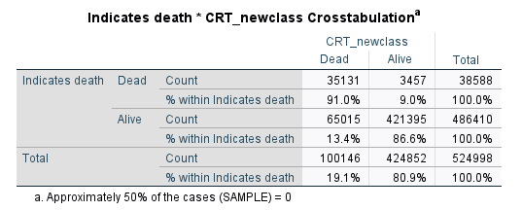
Figure 29
Disclaimer: Threshold is 0.75 to be classified as alive or dead.

Risk = 68472/524998 = 0.130
Sensitivity = 86.6%
Specificity = 91.0%
As shown in figure 29, the risk estimate for the testing data set is 0.130. This means that about 13.0% of the overall responses were incorrectly predicted in the testing set. The sensitivity for the testing set is 86.6% and the specificity for the testing set is 91.1%. Based on the testing set, the model does well at predicting if people lived, and the model also does well at predicting if people died.
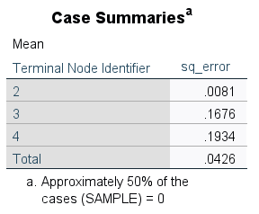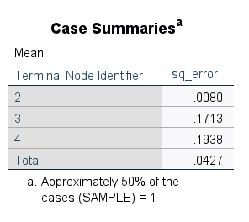
Figure 30
Figure 30 displays the ASE for the training and testing nodes. The average square error for terminal node 4 is 0.1934 and 0.1938. This means that the average squared difference between the predicted values and the actual values is about 0.19. This is the highest average square error of the training and testing nodes, so this means that this node was predicted with the least accuracy. The average square error for terminal node 2 is about 0.008. This means that the average squared difference between the predicted values and the actual values is about 0.008. This is the lowest average square error of the training and testing nodes, so this means that this node was predicted with the most accuracy. This also displays the overall ASE. This means that the average squared difference between the predicted values and the actual values is 0.0426. Lastly, the ASE for the training and testing nodes are very similar to each other, so there does not appear to be overfitting in the data.
Other Logistic Regression models
We ran the Forward Wald and Forward LR options for logistic regression and they both turned out the same when all of the variables were included, so we just went with the first model we ran, which was the Wald method. Then, due to the total number of steps in a logistic regression with all of the variables being 17, we decided to cut off the logistic regression at a step where the data stopped improving for the most part. With this in mind, we stopped the logistic regression after 3 steps with the wald method, and then switched to the enter method with the three variables that were used in the regression model. These three variables ended up being an indication if the patient was connected to the ventilator, an indication if the patient had pneumonia, and the age of the patient. At this step the sensitivity is 93%, the specificity is 42.8%, and the overall correct is 77.4%. The best these become throughout all of the steps is 95% for the sensitivity, 45.5% for the specificity, and 77.9% for the overall, so the step three results are not that far off from the best possible.

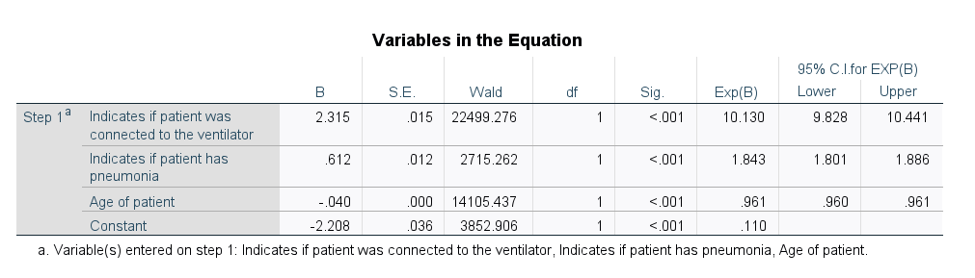
Figure 31

Based on figure 31, it is shown that the variable of the indication if a patient was connected to the ventilator was included first because it had the largest significant Wald statistic. Then, the indication of pneumonia had the next greatest significant Wald statistic. Then, the age of the patient had the next greatest significant Wald statistic. While adjusting for the other variables in the model, the predicted odds of living is 10 times more likely for someone if they are connected to the ventilator. While adjusting for the other variables in the model, the predicted odds of living increases by 88.6% if the patient has pneumonia. While adjusting for the other variables in the model, the predicted odds of living decreases by 3.9% for every 1 additional year in age.

Also, while adjusting for the other variables in the model, we are 95% confident that the predicted odds of living is between 9.8 times and 10.4 times more likely for someone if they are connected to the ventilator.
While adjusting for the other variables in the model, we are 95% confident that the predicted odds of living increase is between 80% and 88.6% if the patient has pneumonia.
While adjusting for the other variables in the model, we are 95% confident that the predicted odds of living decrease is between 3.9% and 4.0% for every additional increase in age.

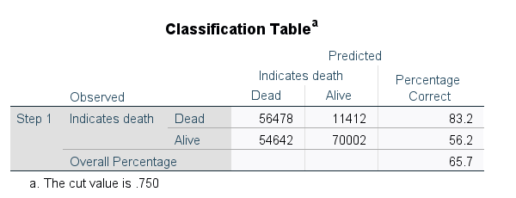
Figure 32
Risk = 100 - 65.7 = 34.3%
Sensitivity = 56.2%
Specificity = 83.2%

As shown in figure 32, this is the best logistic regression model to predict whether a patient lives. To get to this model, the classification value was changed to 0.75 to remain consistent with the threshold of the other models. This cutoff contained an overall percentage correct of 65.7. This means the risk estimate for the data set is 0.343. This means that about 34.3% of the overall responses were incorrectly predicted. Also, based on this the sensitivity is 56.2%, and the specificity is 83.2%. This model is good at predicting if people die, and not good at predicting if people live.

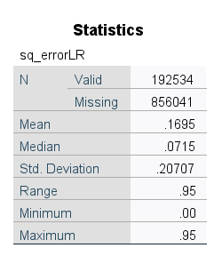
Figure 33
The overall ASE is 0.1695.
Figure 33 displays the overall ASE. This means that the average squared difference between the predicted values and the actual values is 0.1695.
Model Evaluation

 | Risk | Sensitivity | Specificity | ASE
Chaid | 8.5% | 93.0% | 72.2% | 0.0412
Exhaustive Chaid | 8.5% | 93.0% | 72.2% | 0.0413
CART | 13.0% | 86.6% | 91.0% | 0.0426
Logistic Regression | 34.3% | 56.2% | 83.2% | 0.1695
Figure 34

Best Model
As shown in figure 34, the best model selection is kind of tricky. If we want to go by the most correct or lowest risk, then either the Chaid or Exhaustive Chaid model be the best, and the Chaid model would be slightly better than the Exhaustive Chaid. It is clear that the logistic regression model is the worst in all possible categories. The CART model does have a higher risk, but does paint a better story for the patients being predicted as dead, and still maintains a high sensitivity. Also, the value for the risk is going to be inflated due to the sensitivity, since most patients were categorized as alive, and as shown in the descriptive statistics, there was only about 7% to 8% classified as dead. The question then becomes do you want to predict more people as likely to live and possibly have more people die because of this or do you want to predict more people as likely to die and have some people spend money and time to fix an unneeded situation? Under these conditions, we believe the best model is the CART model because, though it is lacking in the best predicting, in a hospital setting, it is the job of the workers to save the most amount of people possible, and this model contains a broader range of who is likely to die.

